Software requirements for TOF Laue Diffraction on single crystals

A.Daoud-aladine, M.J. Gutmann

Introduction:

Principle of the diffraction experiment:
The single crystal experiment consists of recording with pixelated area detectors (the instrument geometrical space), the intensity scattered by a crystal when it is placed in the white neutron beam. As shown in the figure next page, the fixed planes of atoms in the crystal act as mirrors: they pick appropriate wavelengths (λ or ki) of the incident beam, and reflect them in a direction kf given by diffraction condition (the vector normal to the planes has a direction Q which is the bissectrice of (ki,kf) ). The scattered intensity is concentrated in spots called Bragg p eaks. The 3D coordinates of the diffracted vector kf indexes the position of the spot in instrument geometrical space, generally, with the detector number, two coordinates for the pixel position, and one for the time-of-flight (TOF).
Here we exclusively take the viewpoint of the crystallographer (user), not that of the software developer. The user basically wants to work-out (locate/visualize/analyse/integrate) the Bragg peaks either in the instrument geometrical space, or in a physical space called reciprocal space. The reciprocal space is a mathematical abstraction attached to the crystal. It is also a 3D regular grid where each node represents a possible Bragg peak of the crystal. The reciprocal space can be drawn from the crystal characteristics independently of the diffraction experiment. Detector arrays measure only a portion of this reciprocal space defined by the instrument geometry, the time channel boundaries TOF_{min,max} (or equivalently, |ki|=|kf|_{min.max} or λ_{min,max}) and the sample orientation. The sampled portion of reciprocal space is shown for one detector as the shaded region in Fig.1.

Procedure:

Coordinate transforms
Crystallographic calculations require the establishment of the relation between the instrument geometrical space and the reciprocal space. This is obtained through the physical space (Q-space), where the Q-vectors are usually described in the coordinate system (x0,y0,z0) fixed with respect to the instrument. That space is actually only an intermediate space. Useful coordinate conversions operate as follows:
- The relation between the instrument geometrical space and the Q-space are given by the Diffraction Condition: Q=kf-ki, where the coordinates of the diffracted vectors kf generally expressed in the instrument geometrical space, and ki is given by the incident beam direction, and a norm given by |ki|=|kf|=2π/λ.
- As a specificity of any work carried on single crystal, the Q-space is meaningless. The concept of the “UB matrix” permits to relate the Q-space to the sample reciprocal space, where Bragg peaks are indexed as Q=Q=ha*+kb*+lc*. The “UB matrix” defines how the three base vectors (a*,b*,c*) of the 3D reciprocal space attached to the crystal would be oriented with respect to the (x0,y0,z0) frame if all goniometer angles (orientation) were zero.
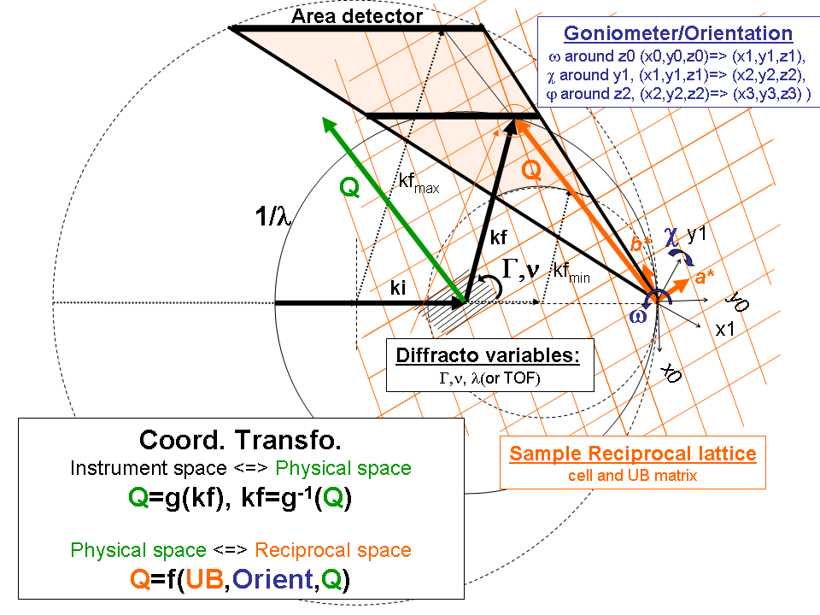
Q coordinates in Q-space are then related to the (hkl) coordinates in reciprocal space by
(Qx,Qy,Qz)=(crystal orientation x UB matrix) (hkl)
Crystallographers are interested in getting data completeness in reciprocal space. The meaning of “data completeness” actually depends on the type of scientific application. To achieve it, it is a common case that other volumes of reciprocal space need to be accessed than those obtained with a single orientation of the crystal. Standard measurements therefore require several orientations, which generally leads to raw data sampling partially overlapped regions in reciprocal space. This is at the heart of the inherent difficulty of the TOF Laue technique.
Some data redundancy is actually beneficial. The common regions of reciprocal space that are measured at different orientations permit the same Q-points to be measured at different wavelengths. This can help to deal with wavelength dependent effects on the Bragg peak intensities, especially absorption and multiple scattering diffraction processes (extinction) within crystals.
We will elaborate later on scientific examples in which cases the crystallographic tasks can be non trivial.

List of common tasks
Software for single crystal TOF Laue diffraction data should include at least:
- Indexation related tasks:
- Peak searching
- “UB matrix” determination without a priori knowledge of orientation
- Indexation for arbitrary crystal orientations.
- Experiment planning (judicious choice of orientations optimizing a data collection)
- Data processing of single raw data in Q-space or instrument space
  - Absorption correction
  - Lorentz factor, solid angle, other geometrical corrections
  - Data operation like substraction, division (for normalisation)
  - Data binning in Q-space
For all these operations there is always a one to one correspondence between input and processed data.
- Data processing (analysis?) merging several raw/processed data in reciprocal space.
As specificity of single crystal work, such a merging uses the different orientations, and would generally lead to data overlap. We shall therefore distinguish such process data as R-processed data. This asks the question of keeping a one to one mapping between the axis of the input data with given in instrument space and the indexation of R-processed data.
- Data reduction (peak integration) of Bragg reflections
  - Integration of a single or a list of Bragg reflections. This should be made flexible, with filters enabling that operation either on:
- a single raw, or Q-processed data corresponding to a single orientation
- in parallel on raw data or Q-processed data collected at different orientations,
- on R-processed data merging different orientations?
Ideally, integration should be scriptable, with the possibility to select different integration methods for subset of reflections in a reflection list.
  - Operations/corrections/filtering on lists of generated integrated intensities: absorption, calculation of absorption corrected path lengths (so-called tbar)
- Visualization
  - It can concern raw, Q-processed and R-processed data represented in 1D, 2D, 3D.
  - Graphical interactivity, like coordinate picking, dynamically link between raw, Q-processed and R-processed data.
  - Interactive data analysis tools
- Hkl based visualization of all data via hkl list browser
- fit parameter picking,
- superposition of visualized data and fit/predictions, like expected Bragg peaks positions, or visualization/analysis (eg. fit) of small piece of data corresponding for instance to single Bragg peaks

Present status of the single crystal software in ISIS
The present software used in ISIS for single crystal diffraction (IDL based SXD2001, from Matthias Gutmann) contains all the necessary calculations (indexation, integration, correction) and fitting procedures of Bragg peaks, as well as facilities to calculate and visualize R-processed data (corrected or not). The set of tools is complete for standard crystallography applications, where “data completeness” consists of optimizing the collection/analysis of an order of a few hundred to a few thousand “anonymous” Braggs peaks (per orientation).
- For experiment planning, the actual graphical “data coverage” tool is perfectly suited to the above need. With only the knowledge of the UB matrix, the user can graphically visualize/simulate the coverage in reciprocal space obtained by a set of selected crystal orientations.
- Integration operates in several modes. It can work out single reflections of a single orientation (“manual integration”). If a single integration method is to be used, integration can also be is automated by acting sequentially on different lists of reflections, which correspond to different raw data associated to different orientations.
However, many tools are not yet adapted to new type of studies, like magnetic structure determination, or diffraction under high pressure, where, the user often wishes to measure, focus and ultimately diagnose an explicit small list of Bragg reflections of <<100 observations.
- For experimental planning, in addition to the graphical data coverage tool, a sort of expert system or an interactive system would be required to facilitate the choice of an appropriate set of orientations optimizing the collection for a user given list of reflection. Some facilities in development stage are present to do that: they still lack for a higher interactivity.
- In the automated integration mode, the user has a limited control on the list of reflections which are on target. The usable list of reflection is either taken from the list of “observed” reflections deduced from peak search procedures, or from an automatically generated list of observable reflections that the user can truncate with few filters. As a limitation, user defined (hkl) lists cannot be given as an input reflection list yet.
- Several limitations are related to the fact that the program always works with ONE currently loaded orientation/raw data. A list of orientations at which a reciprocal space region has been measured can be only obtained manually. Any analysis is bound to be sequential, and cannot be made parallel, with respect to the different orientations collected
- For integration, the information on the extracted Bragg peak intensities is always split in separate files for each orientation. Identification of redundant information requires edition and text search over multiple files
- For reciprocal space exploration/visualization, an interactivity, which could link back R-processed data data to the original raw, or Q-processed data by simple click can be desirable. At present, R-processed data have no correspondence with data described in instrument space (raw, or Q-processed data).
In general, there is no facility to process in parallel (visualize and/or integrate) a set of portions of different raw data collected at different orientation that are sampling the same region of reciprocal space.

Software requirements
From the above points, we delineate two fundamental questions.
The first question concerns the relative importance for single crystal diffraction, of data processing, as opposed to data analysis. In the list of common tasks, except for II all the tools listed correspond to “data analysis” tools.
The second question that has to be kept in mind is the level of mapping that we need between raw and processed data: should processed data always keep track of points in raw data?
We can address the above questions by considering one task, let’s say, the Bragg peak integration. Integration is a complex task as it involves combination of both data processing and data analysis: the order in which elementary operations are done is essentially based on habits.

Where is the data processing and where is data analysis?
At present, the common practice is to work out with uncorrected or partly corrected processed data that are analysed in instrument space separately (or sequentially) for each orientation. The output is made of separate intensity lists (hkl-lists) that, when they are merged together, contain some redundant Bragg reflections measured with different intensities at different orientations. For weak peaks the integration has no reason to be successful for all the orientations: it can fail for some orientation, if the weak Bragg peaks happens to be measured in regions with a high background, low resolution, spurious scattering, etc... Another problem is due to the fact that for TOF Laue diffraction, consistency will also depend on the precision/relevance of the corrections applied (typically, absorption, extinction, Lorentz factor and other geometrical corrections): strong peaks subjected to severe extinction will have always their intensities strongly orientation (hence wavelength) dependant. Overall:
- the quantity of data processing involved is relatively low: it essentially requires a proper normalisation of the data to the vanadium using only a part of the corrections (in the present case, the geometrical corrections and optionally, absorption correction). Extinction is at present systematically dealt after data reduction, by models included in third party programs.
- The data analysis (intensity extraction), which involves 3D fitting procedures.
The present project might offer the opportunity to perform integration in reciprocal space, which could theoretically give a single intensity for each Bragg peak (with the redundant information averaged out). This would define a different practice, which is not obviously superior to the common one described above. Indeed, for that approach, the neutron counts mapped in reciprocal space have to be fully corrected prior to integration. This will require good redundancy of the data otherwise such an approach would be meaningless. There is a priori no major obstacle to make reliable point by point corrections for absorption or some other simple geometrical corrections. However, this is not the case for more complex extinction/multiple scattering effects. Data processing including such corrections would be a level of complexity higher, when the gain for doing that is quite unclear.

Example of an important missing data analysis tool:
All the data analysis facilities are missing a reciprocal space based indexation (or (hkl)-based indexation) of multiple data collected at several orientations (which is a “one to many” correspondence).
Note that such an indexation does not require the data itself, but only the UB matrix, the set of collected orientations and the instrument geometry. A tool like that would permit to work out (visualize/analyse/integrate) sets or subsets of data sampling the same reciprocal space point in parallel.
For example, as far as integration is concerned, information about the status of the treatment of Bragg reflections could be gathered in the following way, rather than being split in different files for each orientation. In the following, “orient label” is an index to a known or desired orientation.

Expected Calculated I sigma Orient Instrument space Flags
H K L H K L label Det xpix zpix TOF Indexed Observed Integrated etc…
[…]
-5 10 2 -4.99 9.99 2.00 -- -- 1 1 25.22 20.00 1332.61 Y N N
2 N N N
-5.00 10.00 2.00 103.5 1.05 3 5 10.59 56.27 3334.84 Y Y Y
[…]

This allows immediate diagnostic, filtering, etc…: the reflection (-5 10 2) has been measured in orientation 1 and 3, but has not been measured in orientation 2. While the integration has been successful for orientations 3 it failed in 1.It is desirable to plot the raw data or perform a parallel integration of that reflection simultaneously, for what all the necessary information accessible in one place when working with a small set of e.g. magnetic reflections.
High level operations on such lists can be defined, like filters based on orientation, flags, input or output values (i.e I/sigma filter), add/remove orientation, etc…

Summary
- Software requirements for single crystal diffraction are essentially concerning data analysis/visualization.
- New software may beneficiate from a generic data processing and visualization engine, but we believe this is an intermediate step only for calculation in Q-space only that represents no more than 20% of the calculations.
- Useful tools like interactive diagnostic of reduced data (intensity lists) or interactive visualization of processed data that keeps a track of the raw data constantly pose the problem of having to deal with the additional coordinate transform from physical space to reciprocal (sample) space involving different crystal orientations as the mapping reduced/processed data with raw data is not a one to one correspondence.

